Output:
1.
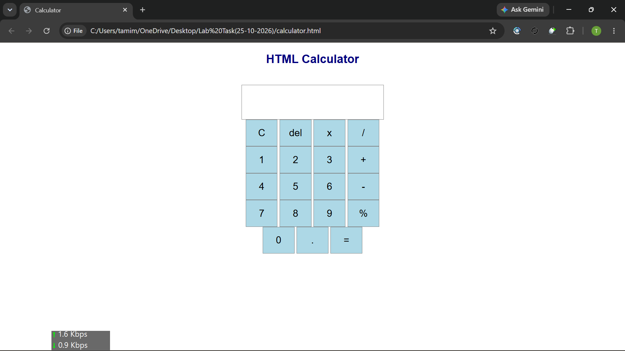
2. 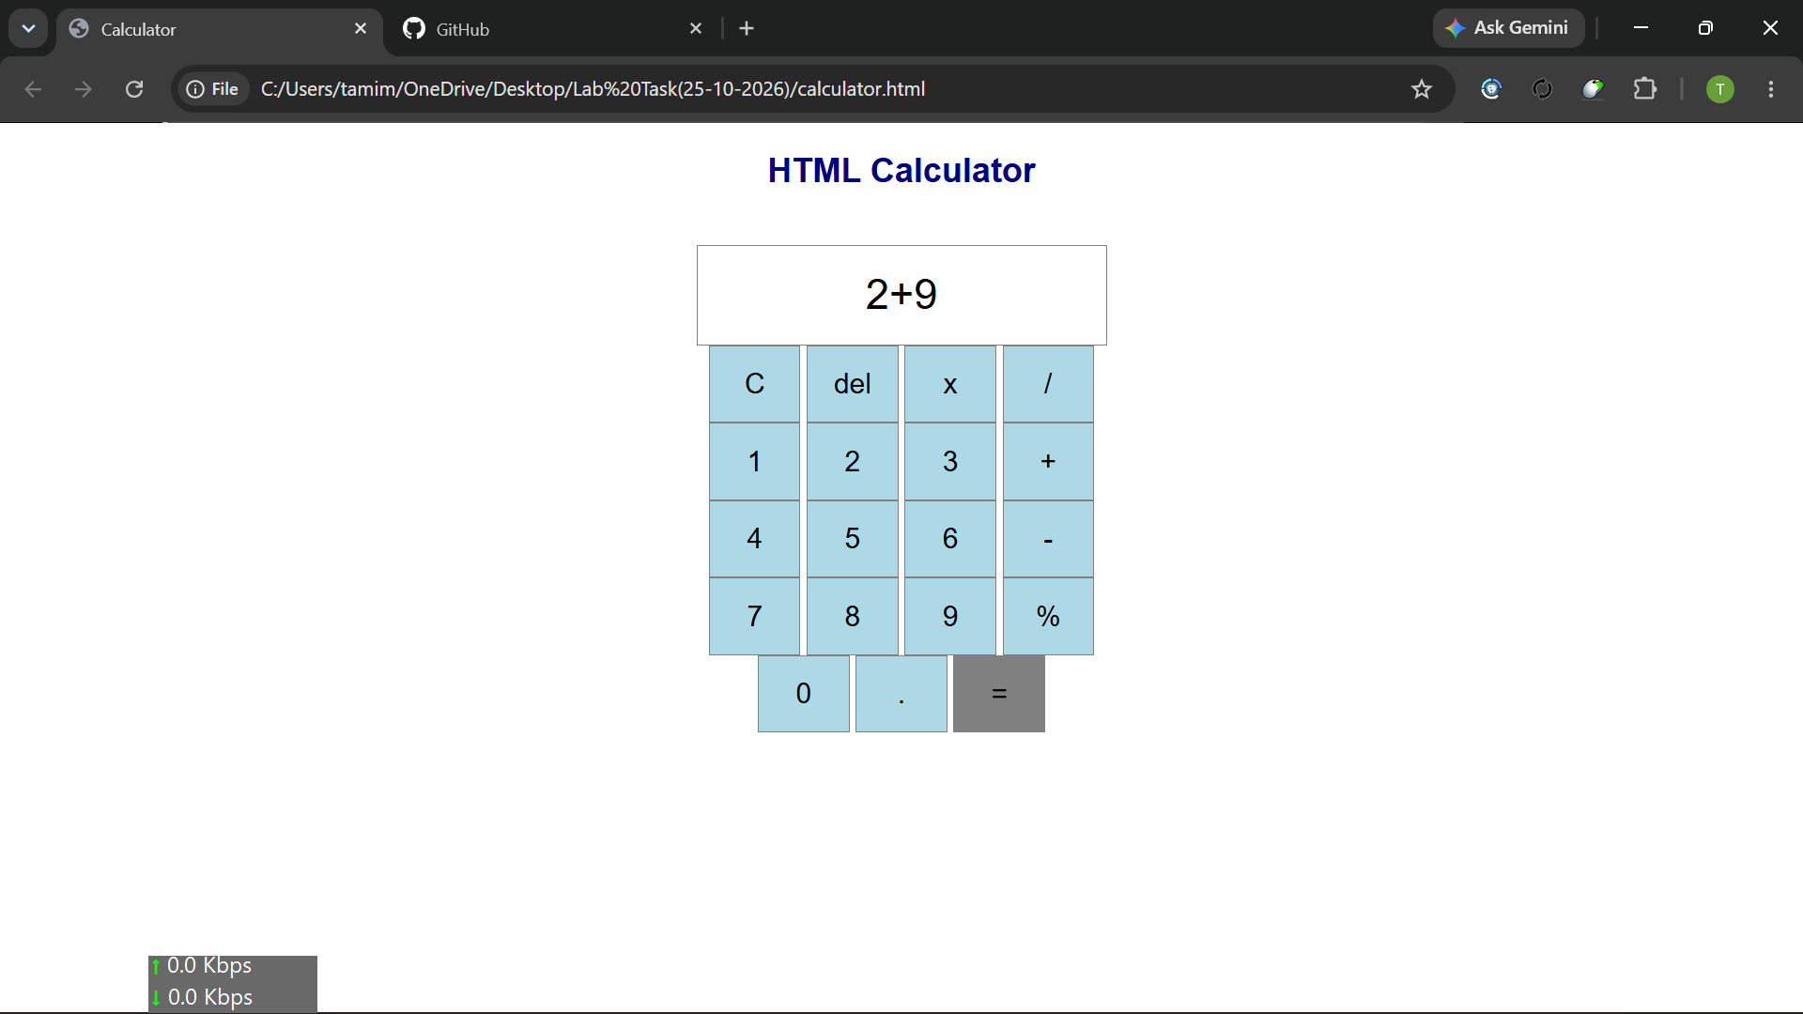

3. 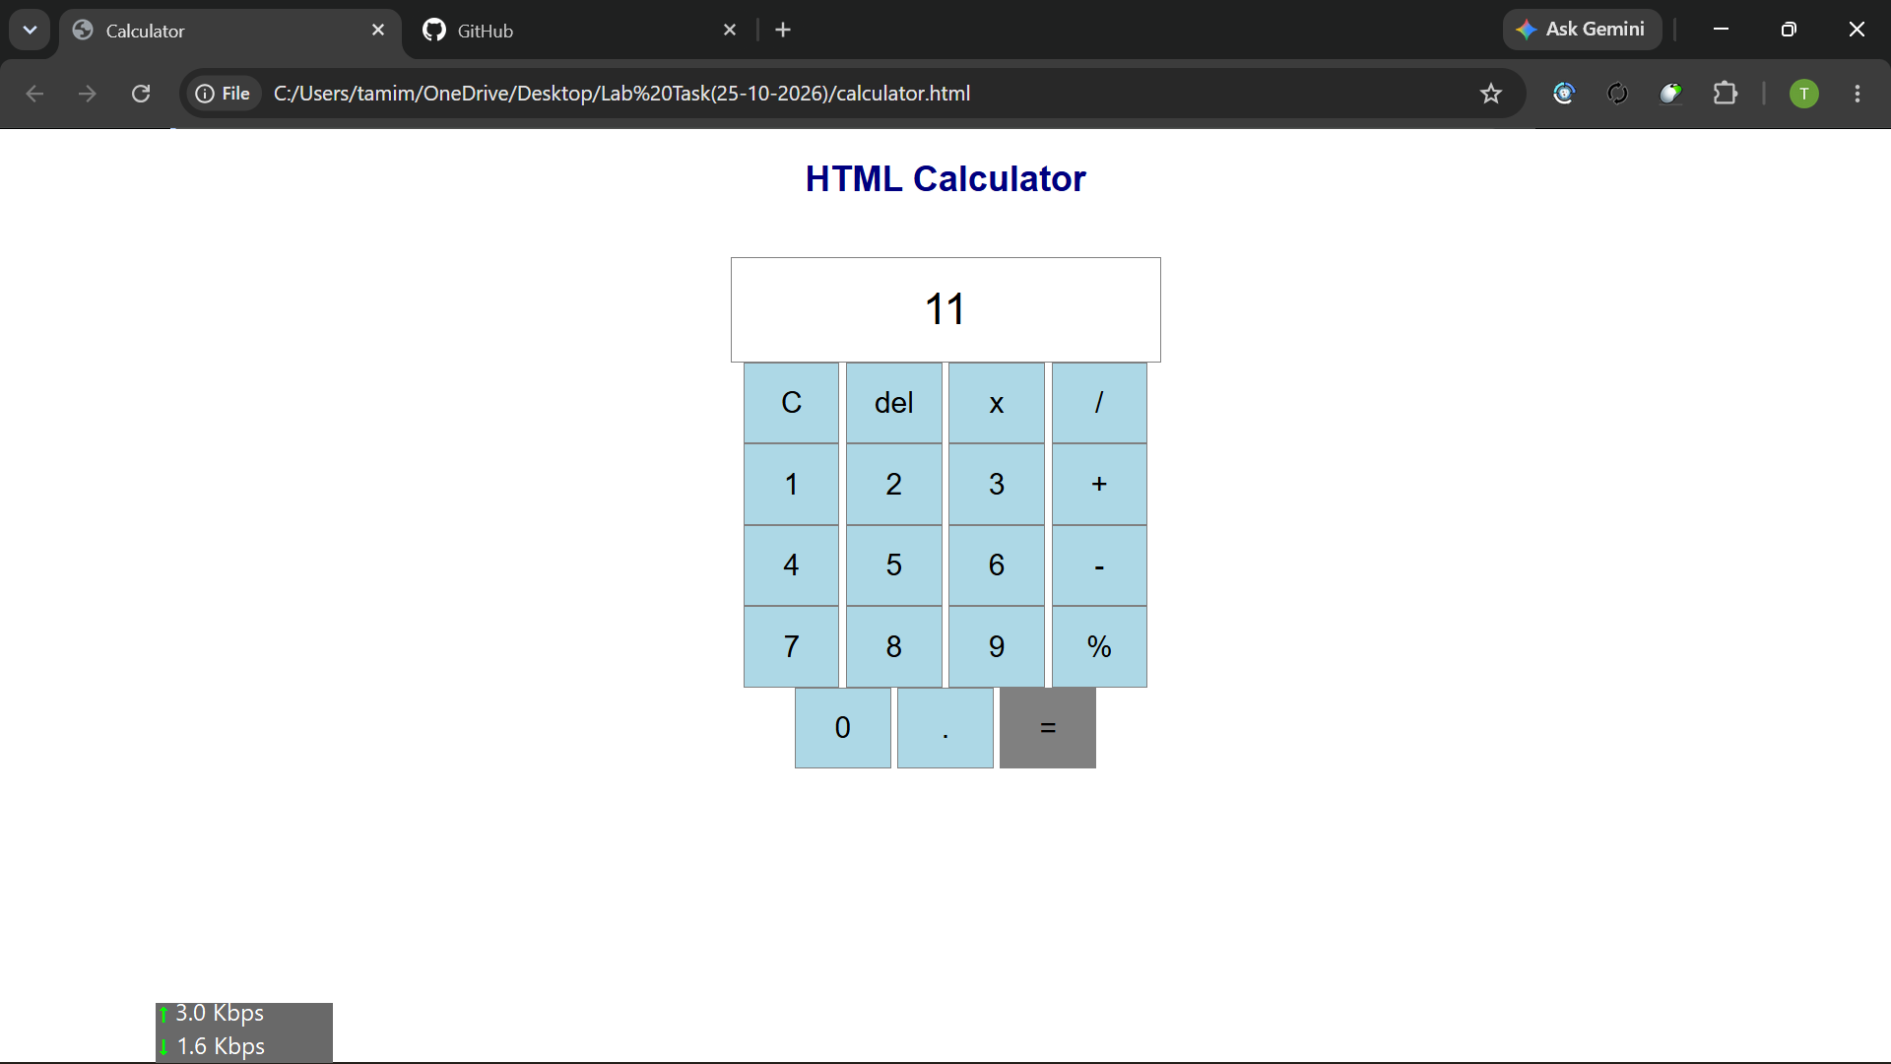
HTML:
<!DOCTYPE html>
<html>
<head>
<title>Calculator</title>
<link rel="stylesheet" href="style.css">
</head>
<body>
<h2>HTML Calculator</h2><br>
<input type="text" name="display" id="display"><br>
<button onclick="clearDisplay()">C</button>
<button onclick="deleteNumber()">del</button>
<button onclick="addValue('*')">x</button>
<button onclick="addValue('/')">/</button><br>
<button onclick="addValue('1')">1</button>
<button onclick="addValue('2')">2</button>
<button onclick="addValue('3')">3</button>
<button onclick="addValue('+')">+ </button><br>
<button onclick="addValue('4')">4</button>
<button onclick="addValue('5')">5</button>
<button onclick="addValue('6')">6</button>
<button onclick="addValue('-')">-</button><br>
<button onclick="addValue('7')">7</button>
<button onclick="addValue('8')">8</button>
<button onclick="addValue('9')">9</button>
<button onclick="addValue('%')">%</button><br>
<button onclick="addValue('0')">0</button>
<button onclick="addValue('.')">.</button>
<button onclick="calculate()">=</button>

<script src="script.js"></script>
</body>
</html>

JS:

function addValue(value) {
document.getElementById("display").value += value;

}
function clearDisplay() {
document.getElementById("display").value ="";
}
function deleteNumber() {
let display =
document.getElementById("display").value;
document.getElementById("display").value =
display.slice(0, display.length - 1);
}
function calculate() {
let expression =
document.getElementById("display").value;
expression = expression.replace(/×/g, "*");
if (expression == "") {
alert("Please Enter a Calculation");
return;
}
let result = eval(expression);
document.getElementById("display").value = result;
}
CSS:
body {
font-family: Arial;
margin: 20px;
background-color: white;
text-align: center;
}
h2 {
color: navy;
}
input {
padding: 5px;
}
#display {
width: 280px;
height: 60px;
font-size: 30px;
text-align: center;
border: 1px solid gray;
background-color: white;
}

button {
padding: 15px;
width: 65px;
height: 55px;
font-size: 20px;
background-color: lightblue;
border: 1px solid gray;
}
button:hover {
background-color: gray;
}

